Sample Midterm

1. Activation and loss functions help transform a model to fit nonlinear spaces

True / False

1. Softmax function transforms a set of K numbers into outputs between 0 and 1

True / False

1. What is the primary role of an activation function in a neural network?
2. To compute the weighted sum of inputs
3. To initialize the weights of the neurons
4. To introduce non-linearity to the model
5. To calculate the loss during training
6. To determine the number of layers in the network

4. What will be the shape of tensor c after executing the following code?

a = torch.tensor([[1, 2, 3],

[4, 5, 6]])

b = torch.tensor([[7, 8, 9]])

c = torch.cat((a, b), dim=0)

1. (2, 3)
2. (3, 3)
3. (1, 9)
4. (3, 2)

5. Describe the three versions of the gradient descent algorithm (Stochastic Gradient Descent, Mini-batch Gradient Descent, and Batch Gradient Descent), discuss their differences

6. Imagine you are building a content moderation system for a social media platform that needs to detect toxic comments. You have access to a small 400-example dataset of comments labeled as "toxic" or "non-toxic". Design a system that can effectively moderate content.

* How would you define the problem? What would be the input and output of your model?
* What kind of model and loss function would you choose and why?
* What are some things you would do to ensure the training of a good (and robust) model?

7. 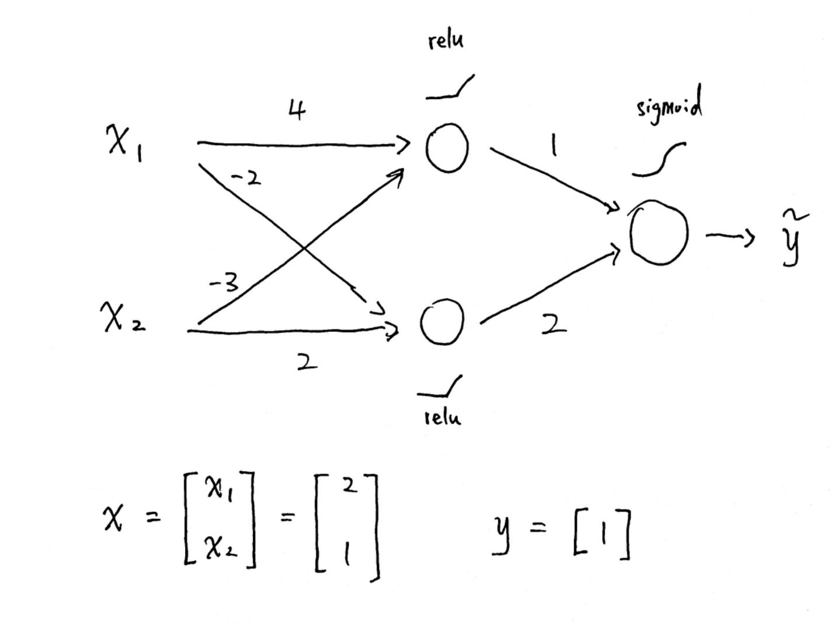

Suppose you have this MLP(used the natural log)

1. Calculate the BCE loss
2. Write down the formula to calculate the gradient of the loss with respect to ***W2*** (the weight matrix of the second layer)
3. Evaluate the formula using the given value

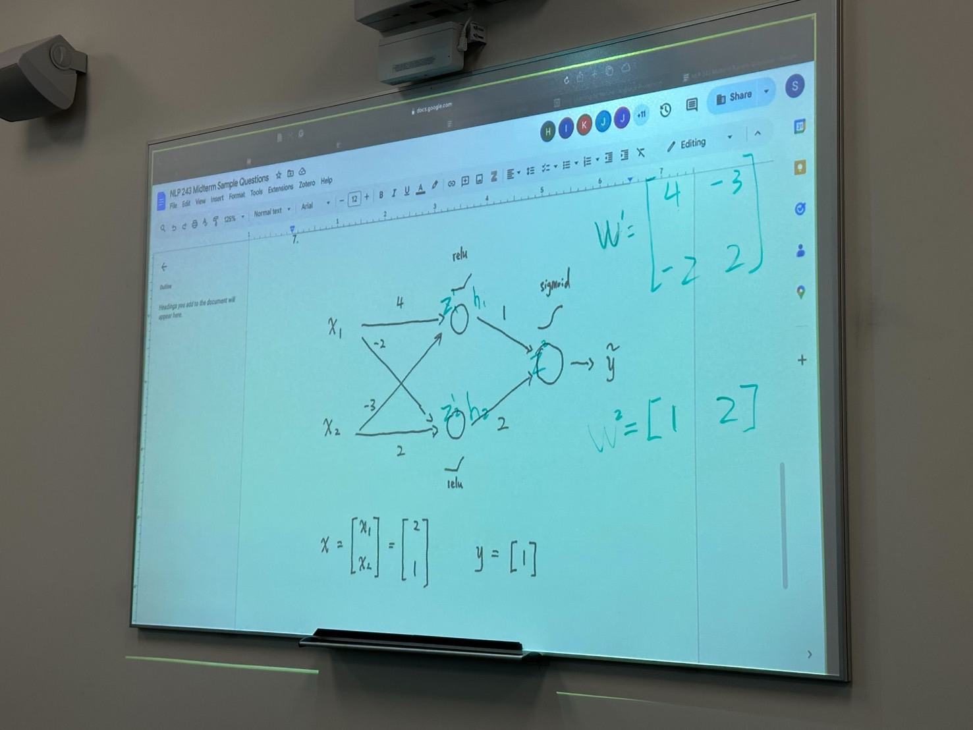Ans 7:

